Phoenix CubeSat – FLIR Lens Venting Analysis

For questions regarding this analysis, contact phoenix.cubesat@gmail.com

I. Overview

The FLIR camera lens is a pressurized component, which must be vented to prevent it from having a positive pressure during launch/ascent and depressurization of the ISS airlock. To accommodate this change in pressure, the Nanoracks Interface Deployer Document specifies that Maximum Effective Vent Ratio (MEVR) must be ≤ 5080 cm. This memo documents the process for determining the size of the vent hole that will meet this requirement for the FLIR camera’s 100mm lens. The vent hole location is shown in Figure 1.
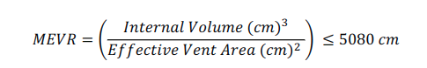

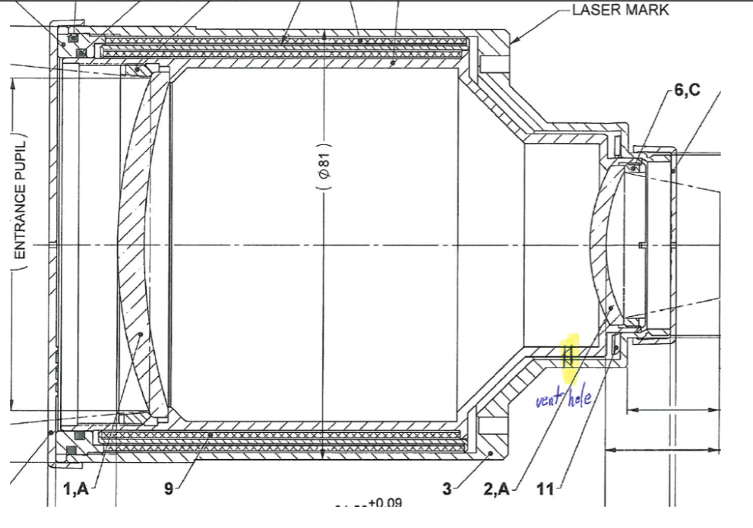
Figure 1: Vent Hole Location

II. Calculations

To determine the vent hole size, the MEVR requirement is used to back solve for the proper hole radius, which can then be used to determine the required drill bit.

The internal volume of the camera’s 100mm lens is 231cm³. This value was given to us by FLIR. The effective vent area is what we need to find ourselves, and what will be solved for through this analysis.

If we want to minimize the hole size (for debris) but still remain within the MEVR requirement, then the safest bet is to take the max required MEVR and apply margin to it so that we are within the requirement. For this, I chose an MEVR value of 4990.

Now, let’s calculate the radius of the bit required to achieve an MEVR of 4490, given the lens’s internal volume.

Area = pi * r^2 = internal volume / MEVR
Drill bit radius = internal volume / (MEVR * pi)
= sqrt [ (231 cm^3) / (4990 * pi)cm ]
= 0.1214 cm
This produces a diameter of 0.2428 cm, or 2.428mm

The closest drill bit to this diameter is a #40 bit. However, a #40 drill bit is quite large, and could cause debris to more easily enter the lens.

To determine a smaller hole size that still meets the requirement, we could divide the total area by 2, and drill 2 #65 holes. This is still within the requirement, as shown in Figure 2.

Based on this analysis, two #65 holes were drilled into the lens for Phoenix. The resulting holes are shown in Figure 4. Figure 3 shows the setup for how the hole was drilled.

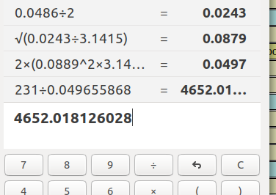
Figure 2: MEVR Requirement Check for Two #65 Holes

III. Drilling & Inspection Processes

Procedure for drilling a larger hole:
- Cover the camera lens with painters’ tape to help mitigate debris (painter’s tape is just easy to remove and doesn’t leave behind any stickiness or small pieces of debris)
  - We used Kapton tape, which worked for us, but can leave behind sticky residue
- Drill into the camera very slowly using a precision milling machine.
  - Get an experienced machinist to do this for you, if you can
  - If you have to do this yourself, use a tapping approach to drill the hole. Lightly tap the drill site with the bit, come back up, then repeat. Go slow.
- While the hole is being drilled, have someone consistently blowing horizontally on the drill site to clear away debris (very important).
  - Do this with compressed air, if possible (much easier)
- Cover the hole with tape immediately afterward to prevent debris from entering the lens.
- Repeat the process second hole, if necessary
- When you get to a clean space, remove both layers of tape and inspect the hole for debris. There will likely be some that you will need to clean off. You can try to collect small pieces of debris by dabbing at the hole using tape to collect it on the sticky side and cleaning with IPA.
- Cover the hole again and store until the payload is ready to be integrated during flight assemlby

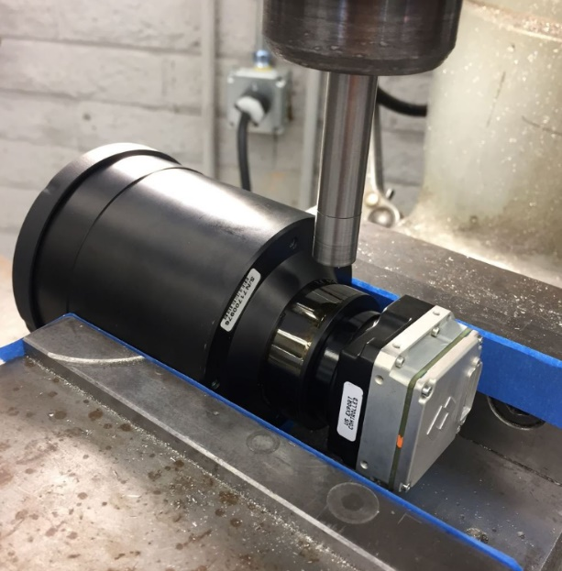
Figure 3: Camera on the mill - in cutting position

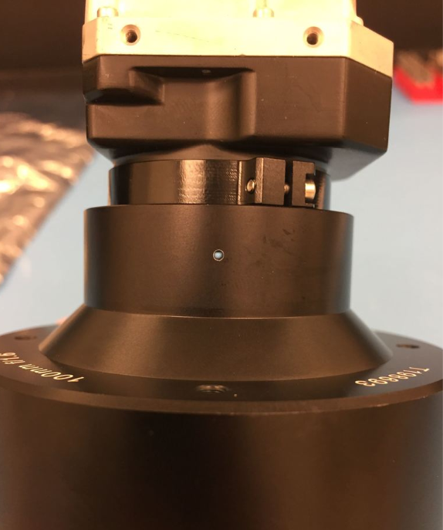
Figure 4: Vent Hole Inspection

